What is Azure Automation Account?
Azure Automation is a cloud-based Microsoft Azure service that lets you automate, schedule, and orchestrate tasks across Azure on-premises, and other cloud environments. It helps reduce manual effort, improve consistency, and manage large or complex cloud operations reliably.
Azure Automation delivers a cloud-based automation service that supports consistent management across your Azure and non-Azure environments. It includes process automation, configuration management, shared capabilities, and heterogeneous features.
Why Automation is needed?
Automation is needed in three broad areas of cloud operations:
- Deploy and manage - Deliver repeatable and consistent infrastructure as code.
- Response - Create event-based automation to diagnose and resolve issues.
- Orchestrate - Orchestrate and integrate your automation with other Azure or third party services and products.

What Azure Automation Provides:
1. Runbooks (Process Automation):
- Scripts that automate tasks such as starting/stopping VMs, cleaning resources, patching servers, etc.
- Written in:
  - PowerShell
  - PowerShell Workflow
  - Python
2. Update Management:
- Automatically manages patching for Windows and Linux machines.
- Works for Azure VMs, on-prem servers, and other cloud VMs.
3. Configuration Management:
- Uses Desired State Configuration (DSC) to enforce configuration standards across servers.
- Helps maintain compliance for infrastructure settings.
4. Hybrid Runbook Workers:
- Lets runbooks run on on-premises machines or networks that cannot be directly accessed from Azure.
- Useful for enterprise or hybrid cloud setups.
Why It’s Useful?
- Reduces manual operations
- Ensures consistency and compliance
- Enables scheduled tasks (e.g., shut down VMs at night)
- Works across cloud and on-premises
- Integrates with Azure Monitor and other Azure services
Example Use Cases:
- Start/stop VM schedules to save costs
- Automatic server patching
- Provisioning and configuring new machines
- Cleaning unused resources
- Enforcing security baselines
Azure Automation Account Architecture:

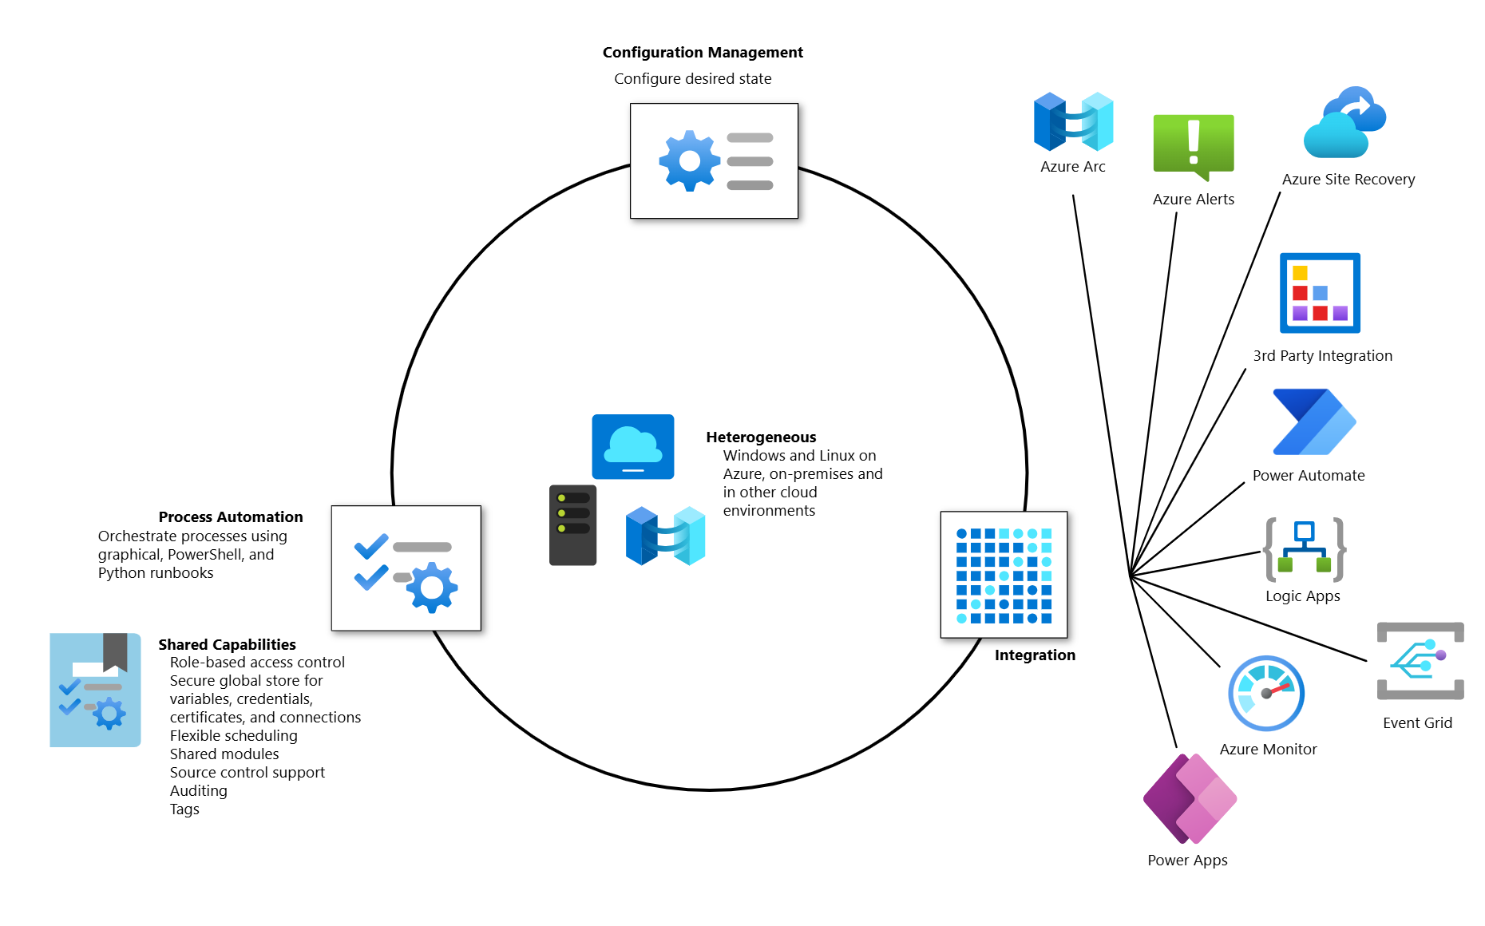

Some Important features of Azure Automation account:
Process Automation:
Process Automation in Azure Automation allows you to automate frequent, time-consuming, and error-prone management tasks. This service helps you focus on work that adds business value. By reducing errors and boosting efficiency, it also helps to lower your operational costs. Following services are include in the Process Automation:
- Runbook: It contains the logic (PowerShell script, Python script, or graphical steps) that automates operations in Azure or on-premises systems. A runbook in an Azure Automation Account is A script or workflow that Azure Automation executes to perform automated tasks.
- Hybrid worker groups: Runbooks in Azure Automation might not have access to resources in other clouds or in your on-premises environment because they run on the Azure cloud platform. You can use the Hybrid Runbook Worker feature of Azure Automation to run runbooks directly on the on-premises machine.

To run runbooks directly on the Windows or Linux machine in the on-premises or other cloud environment, you can deploy a Hybrid Runbook Worker to the machine.

Azure Automation provides native integration of the Hybrid Runbook Worker role through the Azure virtual machine (VM) extension framework, by installing the Hybrid Runbook Worker VM extension. The Azure VM agent is responsible for management of the extension on Azure VMs on Windows and Linux VMs, and Azure Connected Machine agent on Non-Azure machines including Azure Arc-enabled Servers and Azure Arc-enabled VMware vSphere.
- Jobs: In Azure Automation (Process Automation), a Job is the actual execution instance of a runbook.

Webhooks:
Webhooks let you fulfill requests and ensure continuous delivery and operations by triggering automation from Azure Logic Apps, Azure Function, ITSM product or service, DevOps, and monitoring systems.
Configuration Management:
Configuration Management in Azure Automation is supported by Azure Automation State Configuration capability.
Azure Automation State Configuration is a cloud-based feature for PowerShell desired state configuration (DSC) that provides services for enterprise environments. Using this feature, you can manage your DSC resources in Azure Automation and apply configurations to virtual or physical machines from a DSC pull server in the Azure cloud.
Shared resources:
Azure Automation consists of a set of shared resources that make it easier to automate and configure your environments at scale.
- Schedules - Trigger Automation operations at predefined times.
- Modules - Manage Azure and other systems. You can import modules into the Automation account for Microsoft, third-party, community, and custom-defined cmdlets and DSC resources.
- Python packages - Support Python 2 and 3 runbooks for your Automation account.
- Credentials - Securely store sensitive information that runbooks and configurations can use at runtime.
- Connections - Store name-value pairs of common information for connections to systems. The module author defines connections in runbooks and configurations for use at runtime.
- Certificates - Define information to be used in authentication and securing of deployed resources when accessed by runbooks or DSC configurations at runtime.
- Variables - Hold content that can be used across runbooks and configurations. You can change variable values without having to modify any of the runbooks or configurations that reference them.

